University of Rajshahi

Department of Computer Science and Engineering

B.Sc.Engg.Part-1 Odd Semester, Examination-2017

Course: APEE 1131 (Electrical Circuit and Electronics)

Time: 3Hrs. Full Marks : 52.5

[Answer SIX (06) questions taking at least THREE (03) from each Section]

Section A

1. 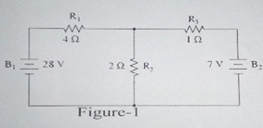(a) Write the steps of branch current analysis method.

(b) What is passive sign convention? What do you mean by linear and

bilateral components?

(c) Find the current through each resistor and voltage drop across each

resistor of the circuit using branch analysis method in figure-1.

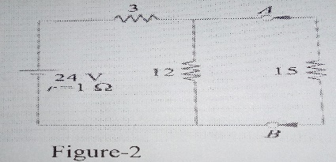2.(a) What is a PN junction diode?

(b) Define conductor, semiconductor and insulator with energy

band diagram.

(c) Explain the I-V characteristic of PN junction diode in forward

and reverse bias with proper diagram.

(d) How is depletion layer formed in a PN junction diode? Explain with energy band diagram.

3.(a) State and explain Thevenin’s theorem.

(b) With reference to the network of figure-2, by applying Thevenin’s theorem find:

(i) The equivalent e.m.f of the network when viewed from terminals A and B.

(ii) The equivalent resistance of the network when looked from terminals A and B.

(iii) Current in the load resistance RL of 15Ω.

4.(a) What are the different kinds of filters?

(b) Deduce an expression for cut-off frequency of a high pass filter.

(c) A filter section is to have a characteristic impedance at zero frequency of 600Ω and a cut-off

frequency at 5MHz design (i)a low-pass *T* section filter, and (ii) a low-pass π section filter to meet these requirement.

Section B

5.(a) Draw the circuit diagram of an astable multivibrator and discuss its operation.

(b) Explain the principle of operation of a photodiode.

(c) Write short notes on LED and LCD.

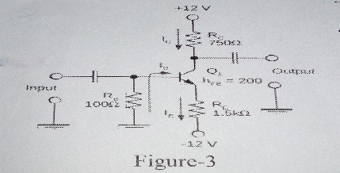6.(a) What is Bipolar Junction Transistor? Explain the architecture of a Bipolar Junction Transistor.

(b) Determine the value of ICQ and VCEQ for the amplifier figure-3.

(c) What is meant by transistor biasing? Why is it needed?

7.(a) Define OP-AMP. What are the characteristic of an ideal OP-AMP?

(b) How can an OP-AMP be used as a differentiator? Explain.

(c) What is inverting and non-inverting amplifiers? Explain with necessary figure.

8.(a) What is an oscillator? What are the conditions for oscillation?

(b) Draw the circuit diagram of Hartley oscillator and describe its principle of operation. Drive equation for oscillator.

(c) Explain positive feedback and negative feedback.